PWA video 22 site audit refresh

<https://www.youtube.com/watch?v=1tkK-OVno84>

repeat the lighthouse audit

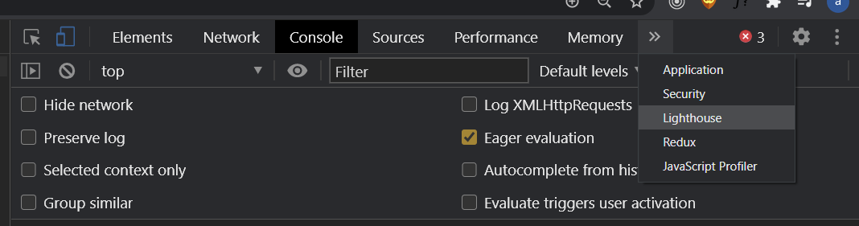

Then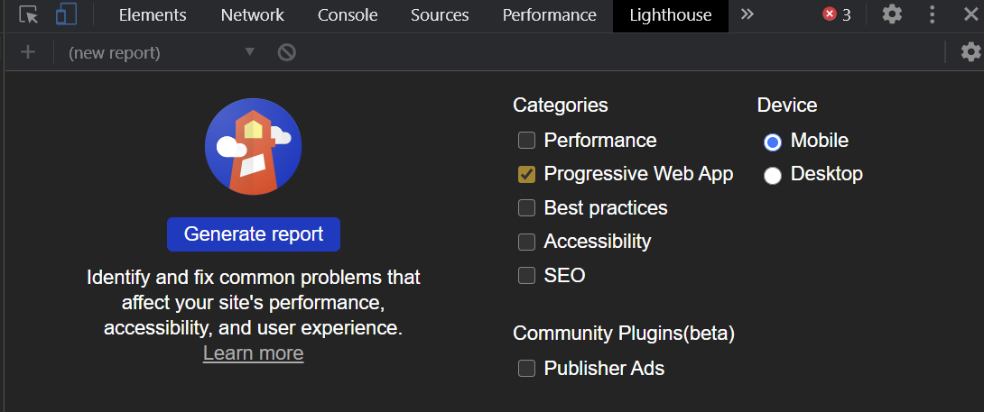

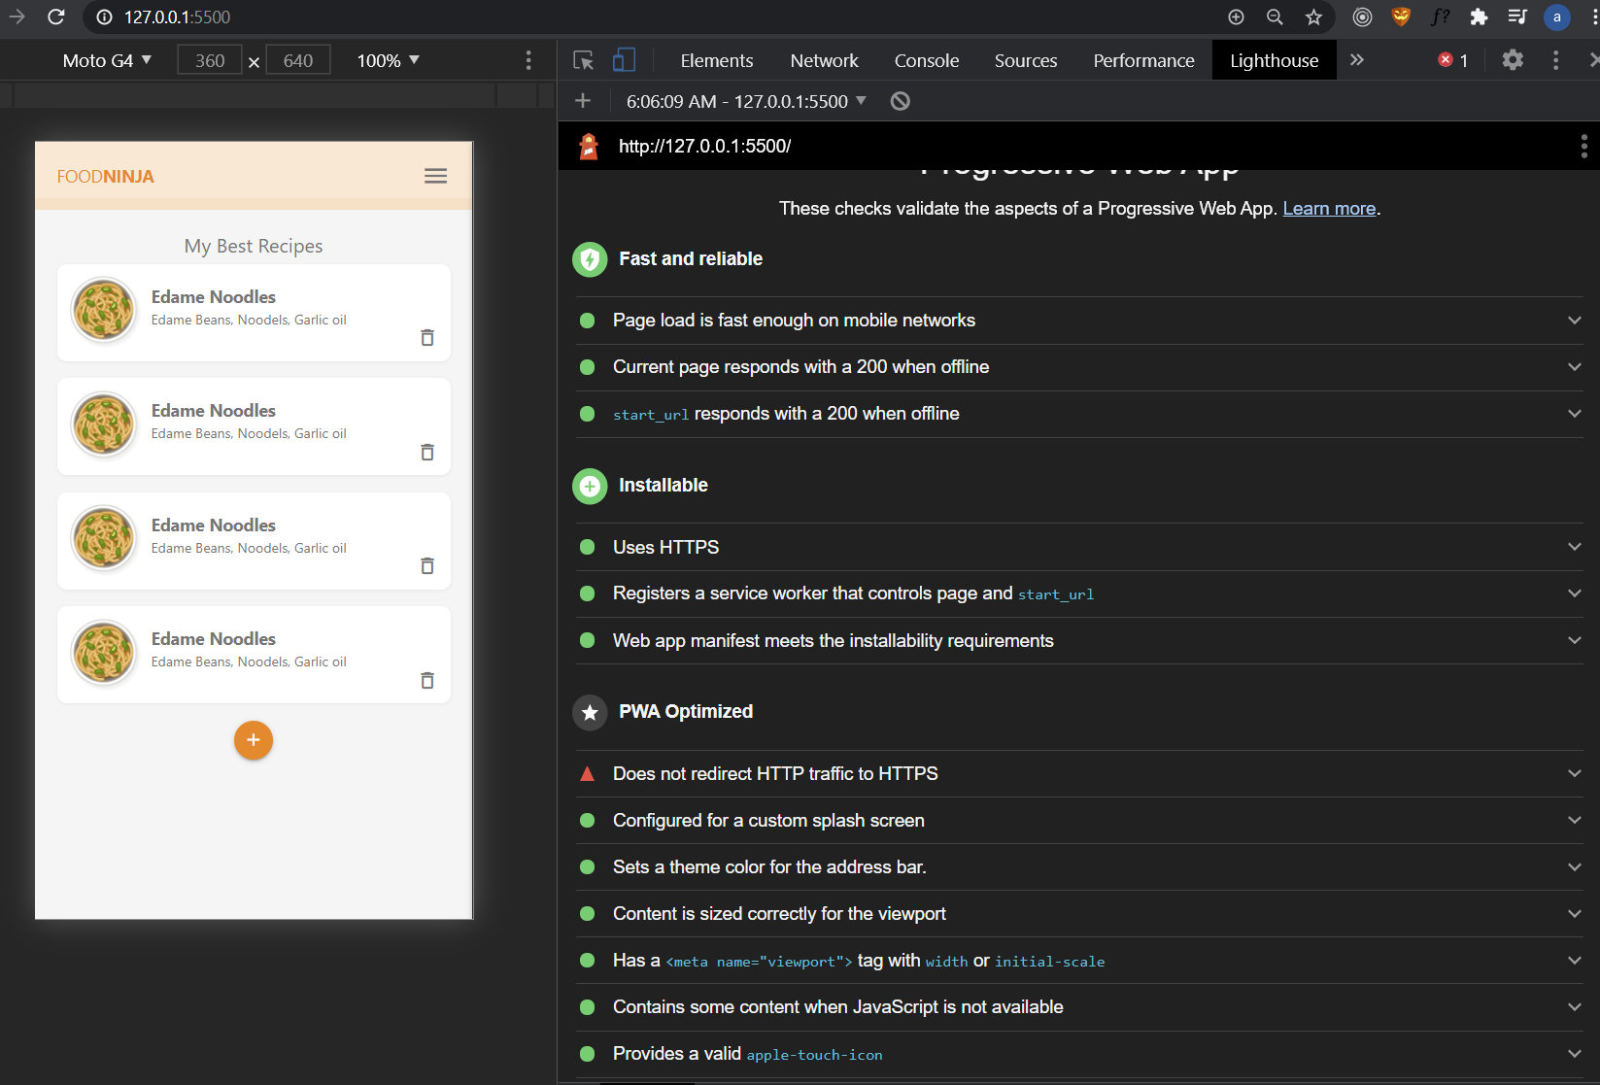

This will be fixed when we deploy to firebase since it redirects to https